--3. Write queries to return the following:

--Find out the number of cities in each state.

Query:

SELECT

count(city) no_of_city,

state

FROM

[dbo].['AUS_Post_suburb']

GROUP BY

State

Output:

--Find out the number of unique postcodes, and suburbs in each city .

Query:

SELECT

COUNT(DISTINCT Postcode) Postcode,

COUNT(DISTINCT Suburb) Suburb,

City

FROM

[dbo].['AUS_Post_suburb']

GROUP BY

City

ORDER BY

Postcode,

Suburb

Output:

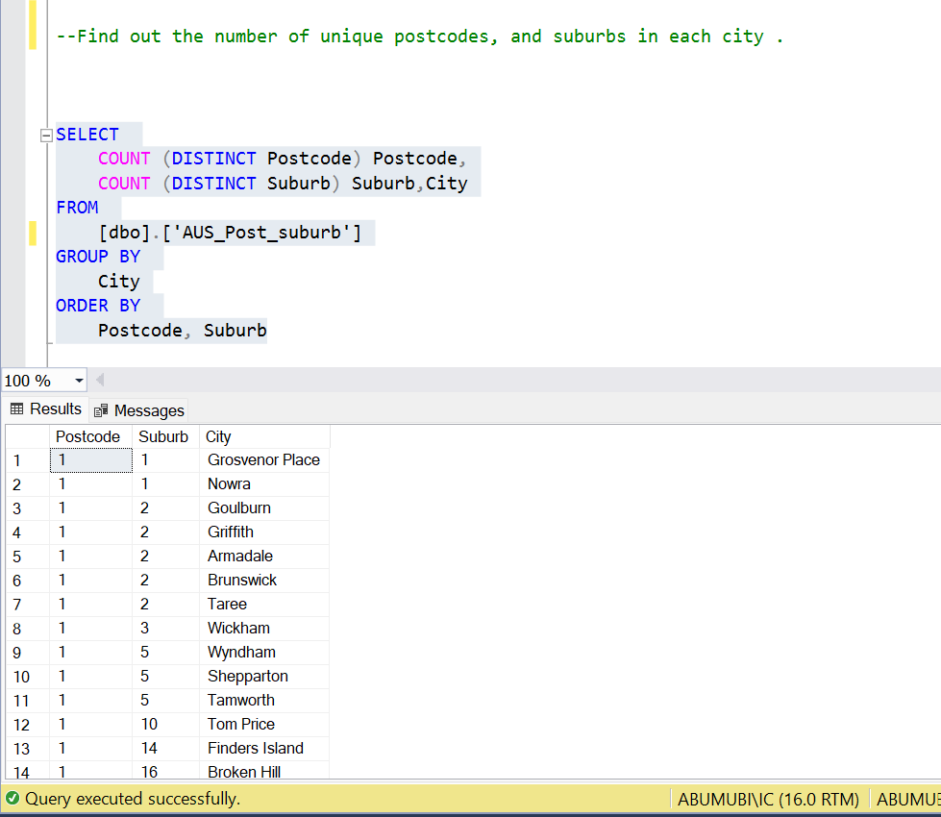

--Query the Average Property Median Value by Suburb, and by Postcode separately,

--and then by Suburb and Postcode together.

--Then put Where condition to remove those records where there is no median value.

Query:

SELECT

avg(Property_Median_Value) Avg_suburb,

Suburb

FROM

[dbo].[NSW_PropertyMedainValue]

GROUP BY

Suburb

Output:

Query:

SELECT

avg(Property_Median_Value) Avg_postcode,

Postcode

FROM

[dbo].[NSW_PropertyMedainValue]

GROUP BY

Postcode

Output:

Query:

SELECT

avg(Property_Median_Value) Avg_of_postcode_and_suburb,

Postcode,

Suburb

FROM

[dbo].[NSW_PropertyMedainValue]

GROUP BY

Suburb,

Postcode

ORDER BY

Postcode

Output:

Query:

SELECT

Property_Median_Value

FROM

[dbo].[NSW_PropertyMedainValue]

WHERE

Property_Median_Value IS NULL;

Output:

